**Sales Forecasting:**

**Objective**: To build a Machine Learning Model to predict the department wide sales for each retail store located in different regions using past dat.

**Model Implementation**: Linear Regression, Decision Tree, Random Forest Regressor

**Model Accuracy**:  **97%**

**Key Insights:**

Analysis of the below graph reveals that store 19 stands out among the listed stores, with the highest sales figure, indicating that this store is performing exceptionally well in generating revenue. Conversely, store 32, at the other end of the spectrum, has the lowest sales figure, indicating that it is not performing well in revenue generation

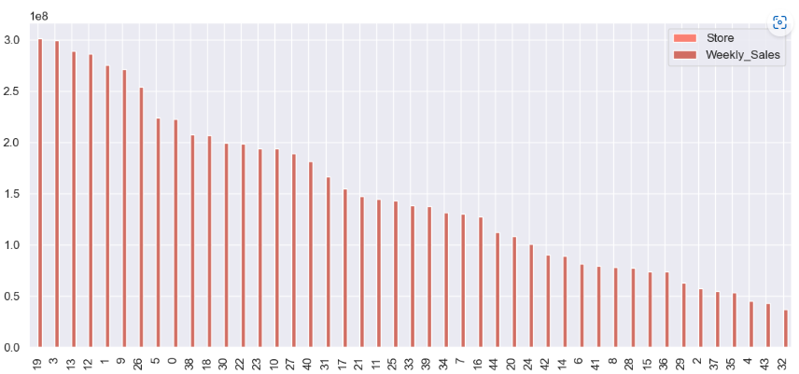

The analysis of the plot reveals that Type A stands out with the highest sales figure compared to the rest of the types. This observation indicates that Type A is the most profitable type in the dataset.The visual representation of data makes it easier to compare and contrast different variables, allowing businesses to identify significant findings that may not be immediately apparent in a tabular format.

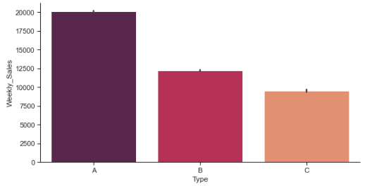

Point plot represents a comparison of the sales figures of different departments in the dataset. The analysis of the plot reveals that Department 92 has the highest sales figure compared to the rest of the departments. This observation indicates that Department 92 is the most profitable department in the dataset

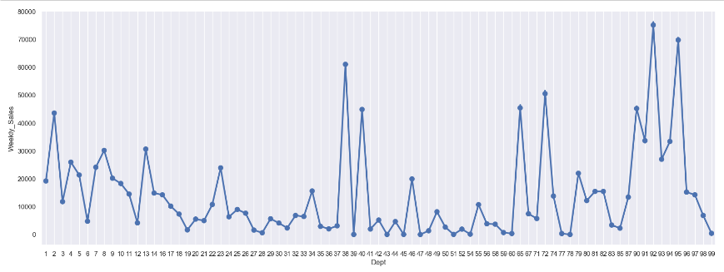

The RandomForest model has the highest accuracy score of 97.06%, lowest MSE and MAE values, and the highest R2 score, indicating that it performs the best at predicting outcomes compared to the other models. The DecisionTree model performs slightly worse than the RandomForest model, while the LinearRegression model performs the worst among the three models which is apparent from the below table

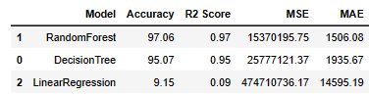

**Conclusion:**

The performance metrics provide essential information to assess the effectiveness of different models. Based on the summary of the performance metrics in this statement, the RandomForest model outperforms the DecisionTree and LinearRegression models.